JP Morgan Chase Electronic Card Application Quick Reference Guide
Last Updated: 5/28/2024
This document provides the steps to complete and submit an application for a Purchasing, Hospitality, or Travel card for the West Lafayette campus.
Jump Links: Access Application, Complete Application, Approval

Access Application
Departmental Dual Purpose is a card to be used by multiple people in a department for purchasing and/or hospitality. | Departmental Dual Purpose
Individual Dual Purpose is a card to be used by a single named individual for purchasing and/or hospitality. | Individual Dual Purpose
Travel is a card to be used by a single named individual for travel related expenses. | Travel

Complete Application
NOTE: Required fields are marked with a red asterisk (*).

General Information
Enter Applicant Information.  - First Full Name  - Last Name  - Date of Birth  - PUID (10 digits)  - PaymentNet User ID  NOTE: For the PaymentNet User ID enter ‘000000’. This field will be completed by the application approver. | 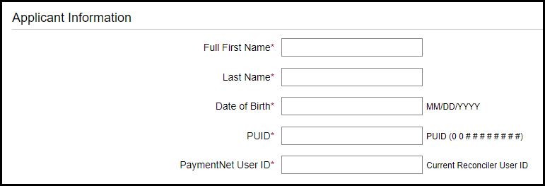
Enter Account Security information.  - Last four of PUID  - Access Code 2 – Mother’s Maiden Last Name (Limited to the first 4 characters) | 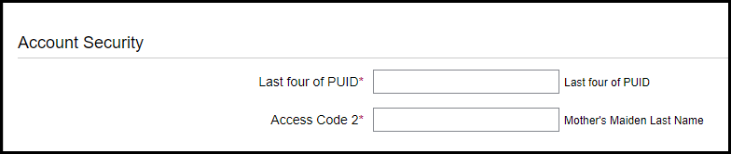
Enter Card Embossing information. This is the way the name will be listed on the card.  - First Name on Card  - Middle Initial (optional)  - Last Name on Card | 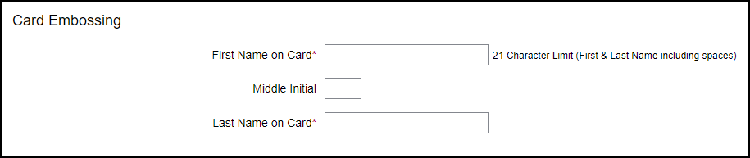
Enter the Contact Information of the individual who will be responsible for the card.  - Purdue Email Address  - Business Phone Number  - Mobile Phone Number (optional) | 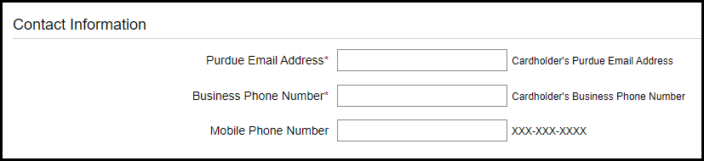
Enter Cardholder Address. This is the address to which the card will be mailed.  - Street Address  - City  - State  - ZIP/Postal Code | 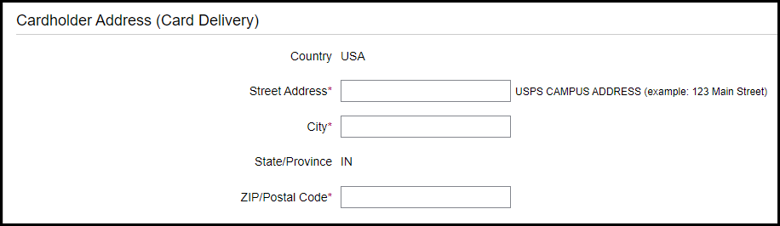
Enter the Home Address of the cardholder.  - Street Address  - City  - State  - ZIP/Postal Code | 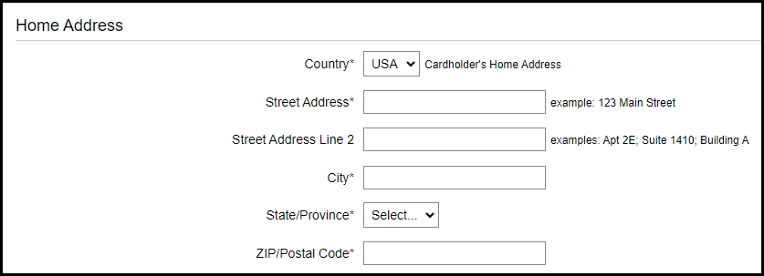
Click Next. | 

Administrative Information
Enter SAP ORG Unit Number. If you are unsure of this number, please contact your business office.  Select Campus.  NOTE: At this time the electronic application is only for the West Lafayette campus. | 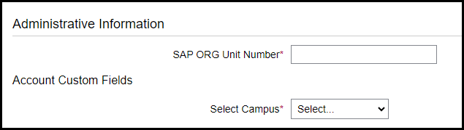  1706000000
Leave the Credit Limit and Single Amount Limit $ field blank. This will be completed by the application approver. | 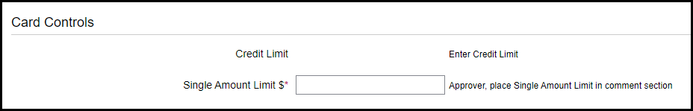
Enter Approval information. This information should be the Business Manager.  - First Name  - Last Name  - Email Address  - Confirm Email Address | 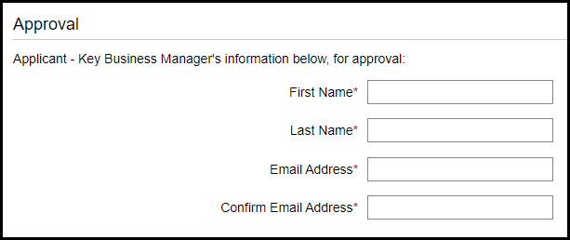  CZahn@purdue.edu  CZahn@purdue.edu  Zahn  Caitlin
Enter any Comments, if needed. | 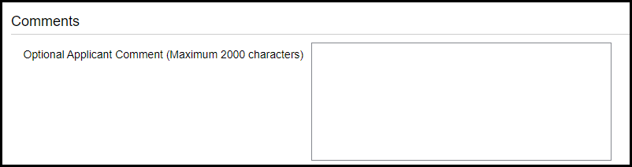
Click Next. | 

Cardholder Acknowledgment
NOTE: The Cardholder Acknowledgement language will differ based on the type of application being submitted.
Click checkboxes to agree to Cardholder Acknowledgement(s).  Click Submit. | 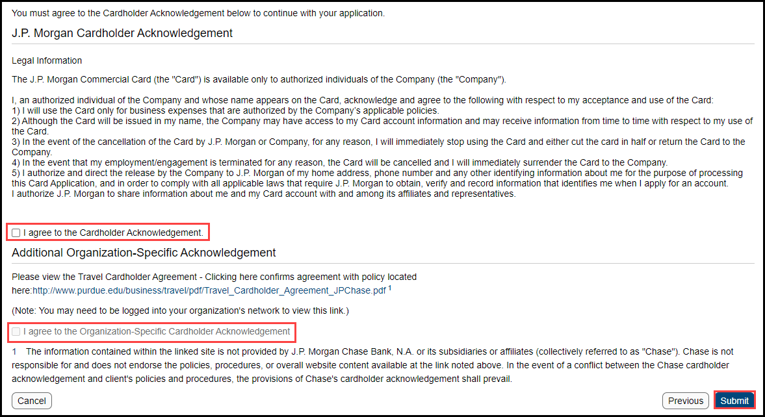
Successful submission is followed by a confirmation screen. | 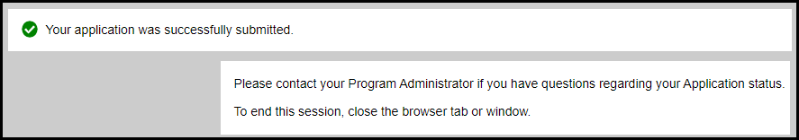
An email confirmation will be sent to the applicant’s email address. | 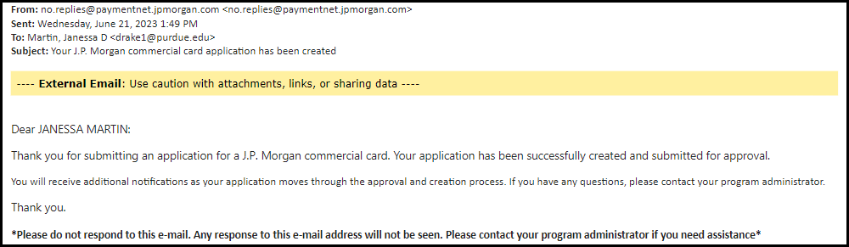

Approval
The application routes to the Business Manager and Central Card Services before being submitted to JP Morgan Chase for card issuance.
If the approver rejects the application, or determines information needs edited, they will reject the application.  Notice of a rejected application will be via email.  A new application must be submitted. | 