Some Tips for Designing Surveys
First: only ask questions for which you know what you will do with the answers. Ask yourself:
- What do you want to know?
- Why do you want to know it?
- What are you going to do with the answers?
There are four things to consider about how your audience will answer your questions:
- Do they understand the question?
- How can they find the answer to the question?
- How will they decide on the answer?
- How will they respond with the answer?
With each question, focus on brevity, familiar words, and only asking one thing at a time.
- Make the answers easy-to-find for your participants. This is why multiple choice is often easier than open-response.
- Also, only ask questions if you know how you’re going to use the answers.
When you know how you’re using the answers, this helps you decide how to ask the question.
Don’t forget to user-test your survey, if you can! Just have a friend or two run through it and give you feedback on their experience. Plus, you can actually see how you can use the answers, since you should only ask questions if you know how you’re using the answers.

→ Let’s practice fixing some survey questions.
Consider which of these questions may work better for respondents and the survey-maker.

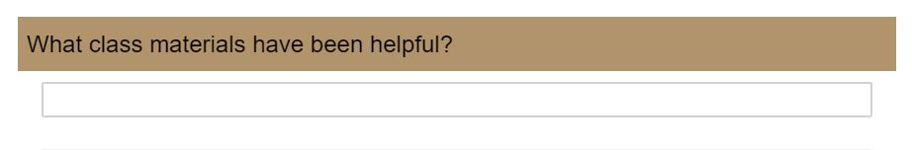
Set 1
What are you asking respondents to recall? How can you prompt their recollection?
What will make this data easier to view and understand later?
Let’s try…
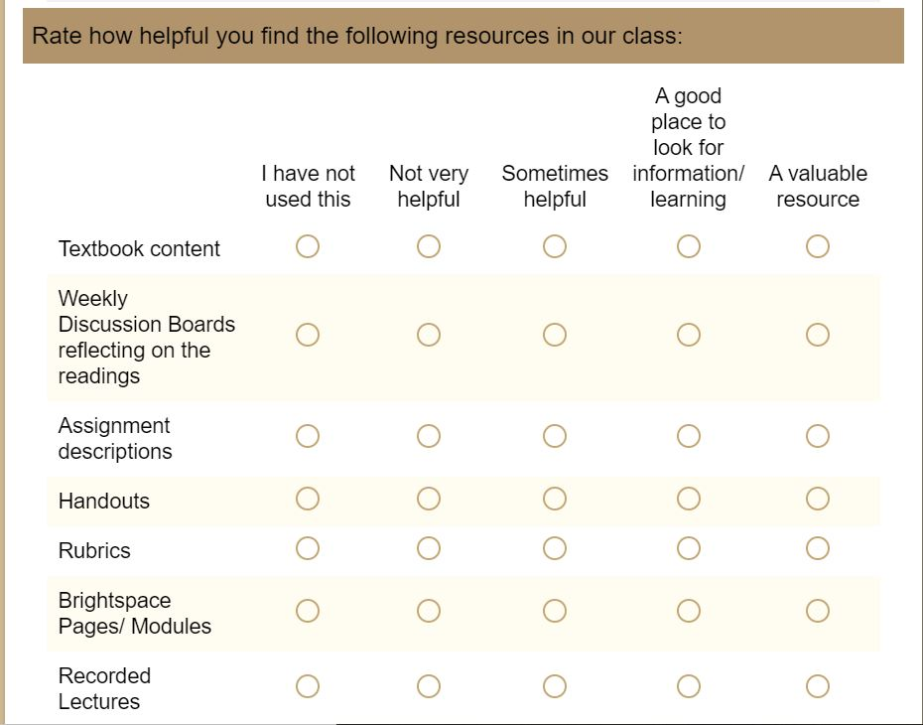

Set 2
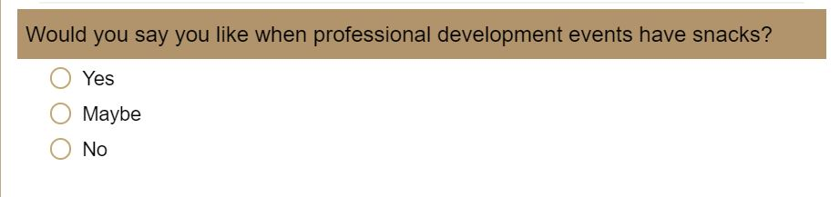
Why are we asking this? What are we actually trying to figure out? What if some snacks suck?

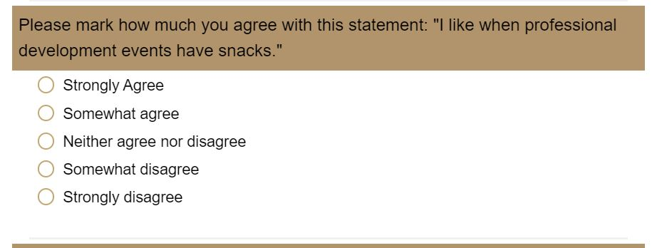

This allows for a little more nuance, but let’s actually ask what we want to know, which is…

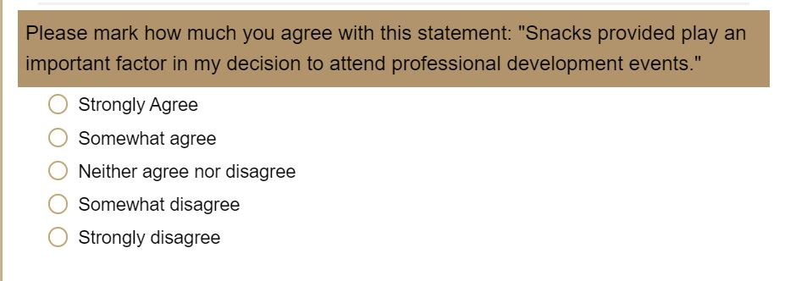

This. :)

Set 3
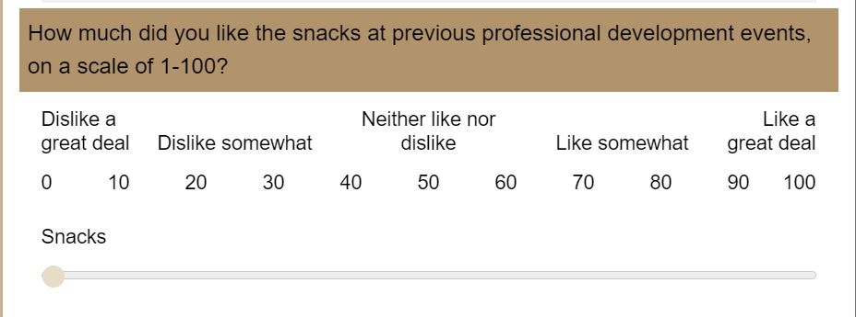
What is this assuming about your respondents?

How will you use this data?

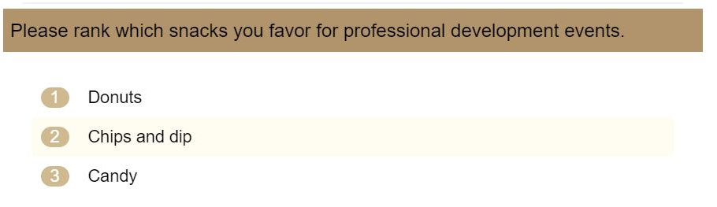
Here–a little more prompting recollection, and you actually find out how much people like which snacks. :)

