https://www.chronicle.com/article/st-johns-college-is-weird-maybe-yours-should-be-more-like-it?sra=true
St. John’s College Is Weird. Maybe Yours Should Be More Like It.
Its Great Books approach is anachronistic, and spreading.
By Beth McMurtrie | May 20, 2026
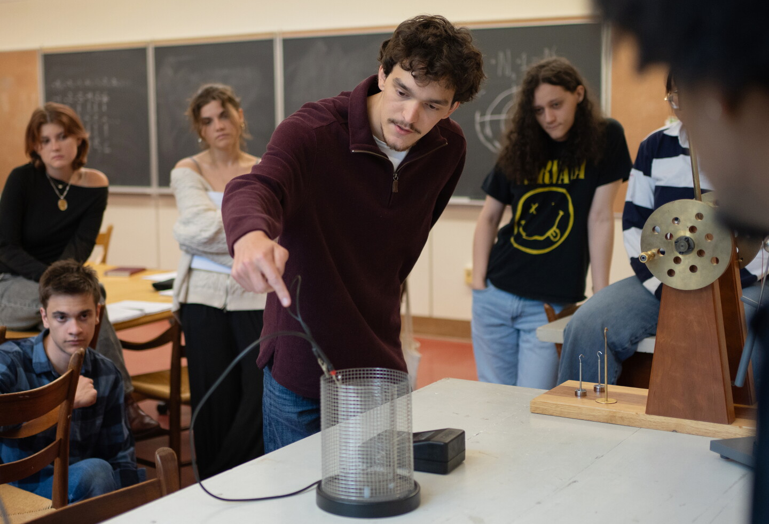
On a bitterly cold January night in Annapolis, Md., students in puffer coats and hoodies made their way along the wind-whipped sidewalks of St. John’s College and into McDowell Hall, an imposing brick building at the heart of campus, for their twice-weekly Great Books seminar.
Thirteen sophomores and two faculty members gathered around a large wooden table in a second-floor classroom, draped their jackets across the college’s famously uncomfortable chairs, and pulled out copies of Dante’s Divine Comedy.

Emily Langston, one of the tutors, as professors are called, began by reading a passage from Purgatorio suggesting that Dante came seeking freedom, and now he was free. Quiet settled over the room as Langston asked: In what sense is he free? And has his understanding of freedom changed?

The students opened their marked-up paperbacks, flipping pages as they considered the questions. There was not a laptop or a cell phone in sight. Then they began an increasingly rare activity on college campuses today. They discussed, for more than two hours, a complicated work and the deeper questions it presents.
Here at St. John’s, people believe that good things happen when students come together to study foundational texts. They take virtually no tests or quizzes. Use no textbooks or learning management systems. Are given no course rubrics or learning outcomes. Instead, they read, discuss, and write.
“Class doesn’t happen if the students don’t take part. One of the things we don’t do is rescue them.”
“We get programmed to think that learning is kind of passive. You listen to people talk, or you read a book and you memorize things and you say the things back in the way that’s appreciated or expected,” Langston told me, as she later reflected on why St. John’s is distinct. “Learning here is really active. Class doesn’t happen if the students don’t take part. One of the things we don’t do is rescue them.”
In an age where colleges compete over who has the most diverse academic offerings, the flashiest technology, and most Instagrammable campus life, St. John’s appears more anachronistic than ever.
Its Great Books approach, which was adopted in 1937, has remained largely unchanged since the 1970s. The tiny campus offers only one undergraduate major. It has no cutting-edge disciplines or high-tech classrooms. In fact, none of the trappings of modern teaching exist here. Instead students make their way in tandem through a series of texts — most of them foundational to the disciplines — over four years together. The cornerstone is the annual seminar. But students also take four years of math, two of Greek, two of French, two of music, and three of science.
St. John’s approach may be unfashionable, but the college has something that many envy: a student body that strives to grow intellectually, embraces ambiguity, and revels in deep reading.
You could argue that it is a self-selected group. In one way that is true: Students here love books. But the demographics of the student body mirror those found elsewhere. Among the class of 2029 at the Annapolis campus and its sister campus, in Santa Fe, N.M., nearly one-third of students are Pell eligible, 22 percent are students of color, and 11 percent are first generation. About half attended public high schools.
Perhaps more significantly, many — if not most — students here struggle mightily with the academic work during their first few months on campus. In other words, St. John’s doesn’t enroll a special tribe of students. It cultivates a love of the hard work of learning from texts and from each other.
That raises a salient question: Is there something about St. John’s countercultural methods that offers hope for fighting the malaise that grips so many college students today?
This kind of teaching has found footing elsewhere. Thanks in part to the work of St. John’s tutors and graduates, as well as foundations like Teagle and Mellon, a growing number of colleges have built programs that focus on small groups of students reading seminal texts. Early adopters say the benefits extend beyond a single class: These courses help students engage in life’s big questions and take ownership of their education. They also foster a sense of community.
Educators have long argued that those are some of the most important ingredients in an intellectually formative college experience. Students must care about what they are learning, feel connected to one another, and have a sense of agency, with professors serving as mentors and guides.
Those elements are in evidence in the St. John’s seminar. Tutors consider themselves fellow learners, not lecturers or experts. They speak infrequently — typically to ask a question, point out helpful parts of a text, or redirect a discussion that has wandered off track. But what happens in any given session is largely up to the students, who do most of the talking. That means one section of a freshman seminar might latch onto one part of the text, while another focuses on something completely different.
Class discussions are typically devoid of heated arguments and showy statements, but students are expected to test each other’s assumptions and interpretations. They often begin a comment with “I was wondering.” It is as if, collectively, they are examining pieces of a puzzle, testing out how each fits with the other and with previous texts they have read.
It is a challenging acculturation process: Students describe feeling lost and ignorant their first semester, bewildered by some of their readings — particularly in math and science — and having to unlearn certain habits and conventions. “In high school it felt like my ideas were where I put my identity and if someone pushed back on it I would take it as a personal insult,” says Jonah Kohn, a student in Langston’s sophomore seminar. “But this shows me that when someone challenges your view, they are showing you respect, in that you are capable of reasoning your way through an argument and changing your mind.”
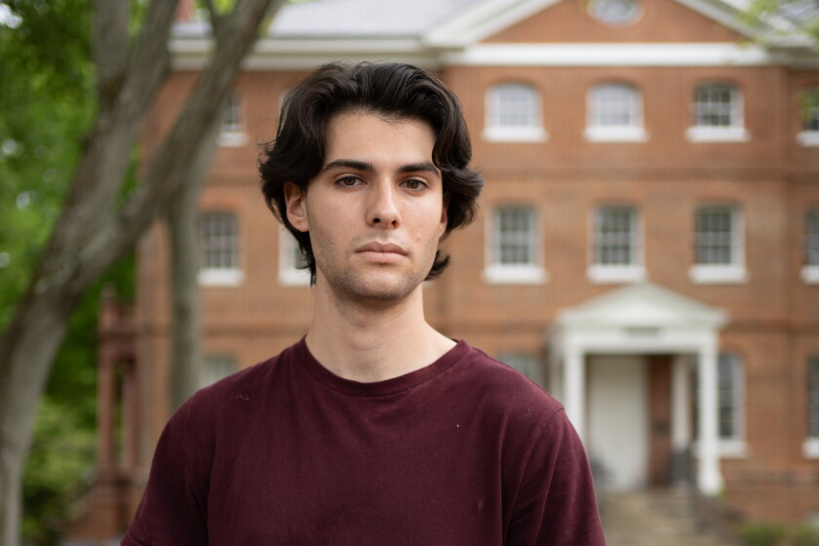
Jonah Kohn, a student at St. John’s, says the seminar classes have taught him that “when someone challenges your view, they are showing you respect.”
On many college campuses, professors complain that if they were to assume everyone came to class prepared, the discussion would fizzle out in minutes. They say students don’t do the reading and are more focused on grades than on learning. Students, meanwhile, often describe their coursework in terms of maximizing efficiency. It is done just in time, sometimes with the aid of AI, squeezed in between their part-time jobs and extracurriculars.
These are symptoms, in part, of a modern higher-education system built around choice and convenience, designed to make education more accessible to a wider range of students, says Peter Felten, executive director of the Center for Engaged Learning at Elon University. Those are good motives, but the structures they have spawned carry a cost.
“We have designed for a disaggregated and isolated student experience,” says Felten, who has written about the importance of relationships to meaningful education. “Then we are surprised when students feel isolated and disconnected and experience their education as transactional.”
Once a week the Student Committee on Instruction gathers in a room just off the campus cafeteria. Anyone can attend or propose a discussion question, as long as it has to do with the curriculum. The committee serves two purposes: to channel the students’ perspective on academic programming at St. John’s to decision makers and, less formally, to discuss what they are reading. The question one week this semester — How do you tell when an author is being ironic? — drew a lively crowd.
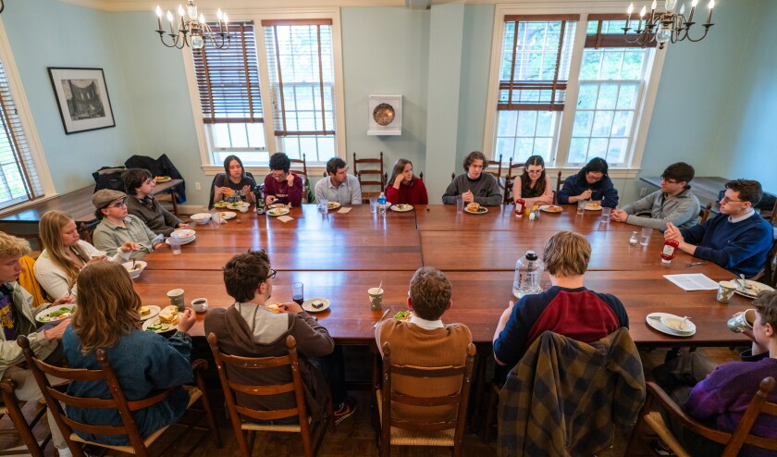
The Student Committee on Instruction acts as a liaison between the student body and the instruction committee.
About 24 students settled in with their lunch trays and launched into a free-wheeling conversation. According to St. John’s convention, they addressed each other as Mr. or Ms., but the feeling was of a classic, late-night bull session — the kind that happened regularly before the internet and smartphones offered students more isolating distractions. One student sat cross-legged on a table; others leaned back in their chairs or laughed when someone made an inside joke.
They discussed how it could be difficult to discern an author’s intent. They questioned whether they imposed their own views when analyzing what someone who lived a long time ago might mean. They considered how some authors might use irony or humor to give cover to their true beliefs.
One student noted that some people find humor in texts others might take seriously or literally. Could “gird your loins” be funny? He thought it was. What about the messenger perpetually misspeaking in Antigone? Or even, another student added, Descartes’ famous statement, “I think, therefore I am”?
The meeting, which broke up after an hour as students headed to class, illustrates an essential element of St. John’s: Conversation about what they are reading doesn’t end when classes do; it continues in dorm rooms, over coffee, and in any one of the dozens of reading groups that form and disband over the months.
Students at St. John’s study far more than what’s on the syllabus, says Millie Ransohoff, who co-chaired the committee this past academic year and graduated in May. “If that weren’t true, the program would fail.” People discover in class what most interests them and then extend that into their free time. “The study-group culture here is crazy.”
Recent groups have focused on Kierkegaard, analytic philosophy, Ralph Waldo Emerson, haiku, and calculus.
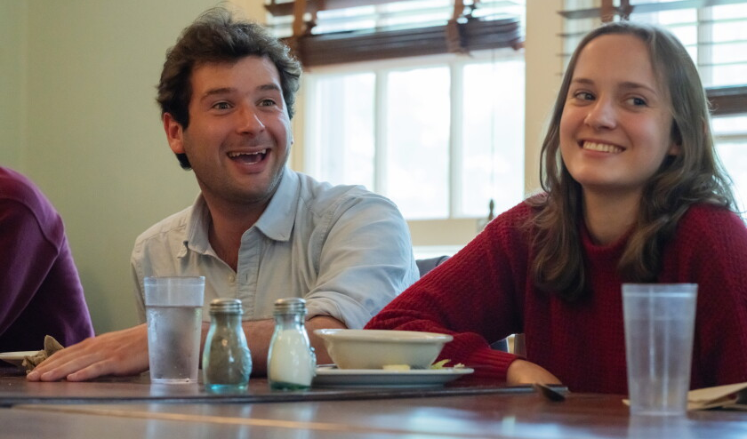
Millie Ransohoff, who graduated in May, said college learning went well beyond the syllabus. She co-chaired the Student Committee on Instruction during the most recent academic year with Nate Burke, seated on her right.
Liesl Geiger, a lanky rising junior from Austin, Tex., who is interested in becoming a math teacher, started the calculus study group. Geiger says she was torn between attending the University of Texas at Austin and St. John’s. She was drawn to the college after attending a couple of its summer programs, but worried that its math curriculum would not be rigorous enough.
Her parents encouraged her to attend St. John’s, focusing on its ability to provide not just an education but a formation. Ultimately, she decided that, while she could take math classes anywhere, St. John’s “was going to be the place where most people care,” she says. “Like, hands down.”
Geiger recalls struggling during her first months at St. John’s because she thought close reading meant she was supposed to focus on things like the plot. But as she watched how upperclassmen approached books in her reading groups, and listened to her tutors and classmates, she came to see the difference.
“What we’re actually supposed to be learning here is not how to read these specific texts, but how to read in general, and how to think in general,” she says. “All of our classes are just sort of exercises in thinking.”
Just as seminars are rooted in the past (though relatively recent authors, including Virginia Woolf, George Eliot, and Toni Morrison, have been added), math, science, and language courses are also taught using foundational texts.
Students start learning geometry, for example, by reading Euclid’s Elements and demonstrating and discussing his theorems. They begin freshman-year science reading Aristotle’s Parts of Animals and dissecting animals and plants. As the years progress, they explore thinkers including Galileo, Newton, Descartes, Einstein, and Bohr, replicating experiments in laboratories, demonstrating mathematical understanding in class, and writing essays that explore core questions and world-changing discoveries.
Susan Paalman, president of the Annapolis campus, recalls that the laboratory program was “make or break” when she considered whether to become a tutor at St. John’s in the 1990s.
“I thought, if I come here and they’re doing fake science, or are not serious about it and don’t do it well, I’m not going to stay,” says Paalman, who earned her doctorate in biophysics and biophysical chemistry at the Johns Hopkins University School of Medicine. “I think now it’s the best science education we’re providing of any that I’ve seen.”
That’s because the curriculum demands that students consider the questions that drive scientific discovery. “They ground our students in a way that I was never grounded,” she says. “I would not trade any of my education, but I didn’t get any sense for what it was that I was doing on a larger scale at all. Certain things were presumed but never examined.”
“I thought, if I come here and they’re doing fake science, or are not serious about it and don’t do it well, I’m not going to stay.”
How well do students keep up with the demanding curriculum? The two St. John’s campuses have a six-year graduation rate of 67 percent for the cohorts completing degrees between 2022 and 2024 compared with 73 percent among their peer institutions. (The figure for the Annapolis campus, which typically has a higher graduation rate than Santa Fe, is 70 percent.) A fair number of dropouts happen freshman year, when some students find that they dislike how seminars are not directed toward a particular set of learning objectives, they struggle to understand the texts they are reading, or they decide that they want to major in one discipline. Many also feel overwhelmed by the variety of demands made of them, such as translating texts from Greek.
Until students are actually sitting in a classroom, says Ron Haflidson, assistant dean for the undergraduate program at the Annapolis campus, “it doesn’t really sink in how strange we are.”
Students who stay remember times when they, too, wondered if they had what it took to succeed.
“I felt like at many points, I just wasn’t up to the task. And I also felt like my fellow students weren’t putting themselves to the task,” says Albert Shapiro, a rising senior. “That happens a lot freshman year, and if you can stick through it, you realize that it’s coming from an intense desire to think deeply and critically and engage with texts intensely.”
Shapiro credits the feeling of mutual confusion — the realization in talking to other students that they felt similarly — and “exemplary figures,” including tutors and older students, with helping him get through the roughest times. He has been struck, when talking to friends at other colleges — often very good colleges — that this communal approach to learning “was not a shared attitude anywhere.”
This rigorous curriculum is just one reason St. John’s can be a tough sell. Like many small liberal arts colleges, it has struggled to attract students in recent years, although it saw a small increase in domestic applications for this fall. About 1,200 to 1,500 students apply annually, with a yield rate of 29 percent, roughly double the average among its peers. About 130 students on average enroll at the Annapolis campus and 100 in Santa Fe. Combined, the two campuses enroll fewer than 1,000 undergraduates.
Benjamin Baum, vice president of enrollment, says St. John’s leans into its distinctions. Every year, about 7,000 students who express interest receive a copy of Plato’s Meno, a Socratic dialogue that is, in part, about the nature of learning.
More recently, St. John’s has found itself competing with large public universities, with their seemingly limitless choices and big-campus atmosphere. “There’s no doubt about it, what we put out to the world is something that is not always the most desired thing for the average high-school student,” says Baum. “And that makes our job in admissions that much harder.”
About a decade ago, in the midst of what St. John’s called “an existential financial crisis,” the college built up its endowment. At the end of fiscal year 2024 it stood at $307,000 per student, while its peers’ averaged $217,000. It began adding more of the kinds of structures found on other college campuses, including mental health and wellness counseling, additional academic support, and enhanced career services. To answer the perpetual question, what can you do with a St. John’s degree, the college created a Career Pathways website that highlights graduates who have gone on to careers in fields including medicine, technology, business, law, and public policy.
Paalman, who has worked at St. John’s since the late 1990s, says the difference between that time, when internship and job placements were often done informally, and now, is striking.
“There’s no doubt about it, what we put out to the world is something that is not always the most desired thing for the average high-school student.”
The college now guarantees paid internships or research fellowships for qualified students. It has extensive partnerships with graduate programs at places like Johns Hopkins, the University of Chicago, and the University of Maryland, some of which offer tuition discounts and a fast-tracked admissions process. Adjusted for size, it ranks 25th nationally in the number of students who go on to earn Ph.D.s. and 15th in sending graduates to law school. A 2024 survey of students who had graduated in the prior five years showed that 78 percent were employed or continuing their education.
Ask students how they have developed at St. John’s and you’ll hear variations of: It taught me to ask better questions and be a more open-minded thinker. It’s not that class discussions are perfect — students describe courses they have taken in which too few people talk, some students clearly didn’t do the reading, or a handful dominate the conversation. But they still find the experience meaningful. They also describe how they have gotten comfortable with the feeling of becoming completely lost, finding their way, then starting all over again. That has given them confidence, they say, that they can figure their way through new challenges and new environments.
Kohn, the student in Langston’s seminar, remembers struggling “to even have a surface-level comprehension” of some of the texts he first encountered at St. John’s. “In my lab class, I don’t think I said a word for the first two weeks,” he says. “My tutor came up to me after class and was like, ‘What’s the deal here?’” Kohn had been very grade-conscious at his large California public high school, but not always in a constructive way. Like a lot of his classmates, he had accrued AP credits to get into a good college but generally “would do the mental calculus of how much effort I had to put in to get the grade I want.” He would read just to find important quotes for an essay or gather a couple of observations for class discussions.
At St. John’s, the tutor gave him some helpful advice: Give an answer you think is right, and the class will explore it together. How different that was from the competition he felt in high school. “Here the goal is not your own personal good-point making,” Kohn says. “It’s all in service of directing conversation toward someplace fulfilling, whatever that may be.”
Students say that another element of St. John’s approach — studying the evolution of ideas and discoveries — helps with that process. It enables them to gauge how our understanding of the world evolved.
“You see the way in which thought develops,” says Ransohoff, who co-chaired the Student Committee on Instruction. “This guy thought this, and then this guy found this thing that didn’t fit, and so then he had to come up with something else, and this guy edited it so that it fit with this other thing that this guy didn’t consider.”
What’s particularly interesting, she says, is that a concept in the laboratory is almost always reflected in the seminar. Her senior science laboratory — which covers biology, genetics, and physics — recently studied Darwin, for example, while her seminar read Nietzsche. Both wrote in the mid- to late-1800s, and students could see the interplay among some of Nietzsche’s ideas, such as the will to power, and Darwin’s theory of evolution.
Discovering that kind of historical interplay is an uncommon experience on most college campuses, where students may choose a selection of general-education courses that have nothing to do with their major. Electives may simply be whatever best fits into their schedule.
If being a student at St. John’s feels radically different than being a student elsewhere, the same is true for faculty members.
Tutors are expected to teach all subjects at some point in their time at St. John’s. As a result, they are fellow learners — reading foundational works and teaching courses in sequence, just as their students take them.
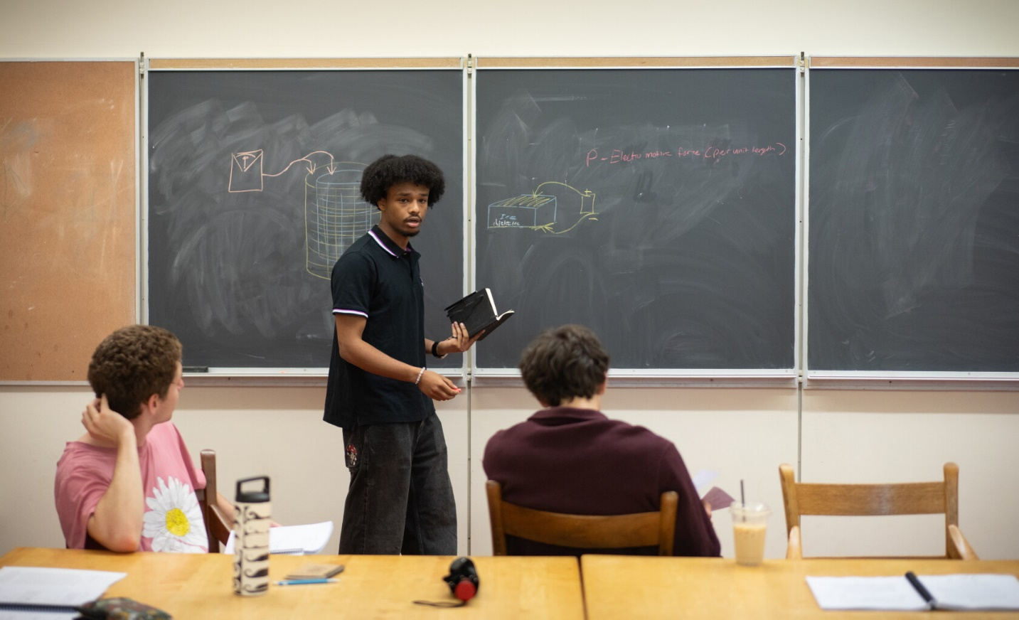
Students at St. John’s tackle questions together. Here Nathan Zewdie leads a class presentation on the results of his group’s experiment on electricity.
At the end of class, a student in a hoodie and sunglasses said he loved it when an experiment disproved his mental model of a thing. “I start to think,” he said before packing up, “what other mental models am I walking around with?”
After class, inside the campus cafe and bookstore where students and tutors often meet, Hitz tells me that time and again she has watched students who had been stultified in high school by rote learning blossom under this approach.
“It’s not for everyone,” she says. “But it’s for more people than you might think.”
Hitz is often on the speaker circuit, talking about the life of the mind and the value of a Great Books curriculum. With her oversized glasses, quick smile, and long brown hair parted in the middle, she comes across as both approachable and deeply serious about her work.
She is herself a Johnnie — as students and alumni call themselves. She earned her undergraduate degree here in 1995 and, because she wanted to pursue research, went on to earn her doctorate from Princeton University. After teaching at McGill University, Auburn University, and the University of Maryland-Baltimore County, she returned to St. John’s in 2015, spurred by a growing dissatisfaction with teaching reluctant undergraduates.
“I was in a kind of dilemma, because to teach philosophy requires holding people to a fairly high standard,” she recalls. “But I realized after a point that if people come to your class because they need to fill a requirement, you can’t punish them for doing that.”
It’s not for everyone. But it’s for more people than you might think.
Before returning to her alma mater, she attempted to create a seminar-style classroom, asking students to dig into Plato’s Republic. But it was like pulling teeth, she says. She was also the only instructor in her department to try that method. At St. John’s, she says, “I can rely on my colleagues to help row the boat.”
That’s just one way in which many of the trappings and tensions of faculty life are absent at St. John’s.
While there is a tenure process, there are no departments, electives, or expectations that faculty members conduct research, which avoids the battles over students, budgets, and other resources you might find at a conventional college.
But that also means that many of the rewards of higher education, including ascending the ranks and securing research grants and publications, are also not available here. The starting salary is $70,700 and raises are based on years of service, topping out around $109,000. St. John’s contributes to tutors’ retirement accounts, but has struggled at times to keep up with cost of living.
“It’s not especially generous and it’s hard to be a tutor, but we don’t have adjunct faculty who are being paid at a different rate,” says Joseph Macfarland, dean of the college at Annapolis.

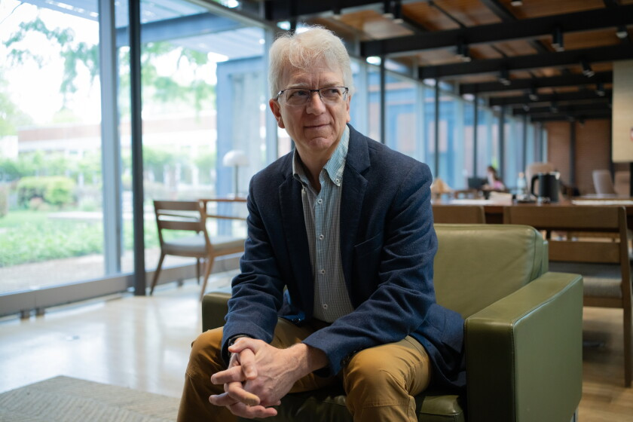
Joseph Macfarland, dean of the college at Annapolis, says faculty pay at St. John’s is lower but more equitable than at many other colleges.
Perhaps it’s not surprising that about a third of the 65 or so tutors are St. John’s graduates, or that tutors’ professional training leans heavily toward the humanities. Macfarland says he would like to hire more scientists and mathematicians, but it’s hard to find people in those disciplines willing to give up research.
Hitz says the pay isn’t great and some people have left for that reason. And the work schedule can be tough on people with families. Tutors teach two evening seminars a week. There is also a Friday night lecture, which everyone is encouraged to attend. Preparing for class is time-consuming because most subjects are outside tutors’ areas of expertise. Even if you taught the same course before, Hitz says, you have to prepare as if you haven’t. Because classes are discussion driven, you don’t control where the conversation will go.
Then there are hours spent meeting with students to discuss a difficulty they might be facing in class or an essay question they want to pursue. (St. John’s tutors do not keep office hours; they mainly meet on or off campus over coffee.) “All of these things are very challenging, and are also what make the job so interesting and so rewarding,” says Hitz. “They are part of the same ball of wax.”
The bonds formed between tutors and students at St. John’s are also distinct.
Each semester during freshman and sophomore year, tutors and students take part in something called a don rag. In that meeting, all of a student’s tutors gather to discuss their progress. The student’s job is mostly to listen, and many say it’s a profound experience to hear how carefully their tutors have been paying attention to them. (Ransohoff called their observations “shockingly accurate.”) By junior year, students can choose to continue the don rag or shift toward a conference, in which they give a report about their work.
During sophomore year, students go through a process called enabling, in which a group of tutors determines whether they are ready to advance. It’s a critical discussion, because junior year is often considered the most challenging. The group assesses whether students are committed to their studies and capable of doing the work, and evaluates their contributions in class, the quality of their writing, and their ability to stay on top of the work. Macfarland says that typically the group focuses on about 12 students who seem to be at risk, and about half of those are not allowed to advance. (St. John’s is not immune to common problems: In the past couple of years, AI misuse has been an increasing concern.)
Because St. John’s believes grades have a “pernicious effect” on learning, it plays them down; they are used mainly for reasons such as applying to graduate school, and students must email the registrar’s office to see them. The most meaningful evaluations, tutors and students say, come in the feedback given in class, one-on-one with tutors, in don rags, and on essays.
Only a few exams are given in the four years students are at St. John’s. Students must pass two written competency tests, on algebra and on music notation, during their freshman year. All other exams are oral and based, during the first three years, on a discussion of the texts (in the fall) or on a student essay (in the spring). Macfarland describes them as more of a conversation than a series of questions and answers. Seniors must pass an hourlong public oral exam, in which they and a committee of tutors interrogate the questions raised in their senior essay.
Hitz says that one of the reasons she left mainstream academe was because she felt she was spending so much of her time focused on compliance. Were students doing the reading? Turning in their homework? Showing up for class? At St. John’s, those are still issues for some students, especially in the first year, but they are quickly caught and addressed. There are simply fewer places to hide.
St. John’s can sometimes feel like a campus inside a snow globe. Ask a tutor whether they use an LMS and you are as likely as not to receive a confused look. Students shopping for easy courses, scrolling on phones during class, or arguing over grades, are similarly foreign.
Is what St. John’s has, then, exportable? Not as a whole, no. The deep integration across the curriculum, says Langston, “is very difficult to duplicate outside of the all-encompassing campus culture that we have at St. John’s.”

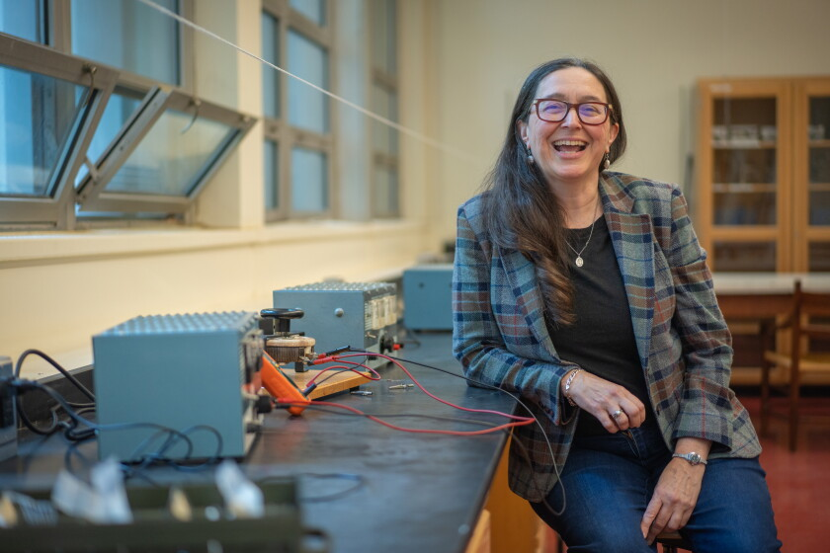
Zena Hitz, a faculty member at St. Johns, is an alum, like many of her colleagues. In previous academic jobs, she wasn’t able to recreate the seminar-style classes she enjoyed as an undergraduate.
But elements of the college’s approach are replicable, and finding fans. What it seems to require are faculty members willing to see themselves as guides rather than experts. It also takes students who want to wrestle with complex and timeless questions.
As it turns out, many students — tired of the transactionalism that has come to dominate higher education — are in search of both of those things, even if they don’t always recognize it.
In their book The Real World of College: What Higher Education Is and What It Can Be, Howard Gardner and Wendy Fishman, of the Harvard Graduate School of Education, capture the alienation students feel when they place all else — résumés, GPAs, jobs, clubs, and internships — above intellectual exploration. The authors argue that colleges can enhance students’ sense of belonging by centering intellectual development as the primary purpose of college.
Felten, of Elon University, says he is supportive of efforts to create discussion-based courses built around meaningful texts. But more impactful, he says, are the beliefs that St. John’s exhibits in its very structure. Namely, that learning is both difficult and a communal act, in which professors and students work together. That, he says, is something any professor can do.
“I don’t think we spend enough time talking with students about how what we’re doing is supposed to be challenging,” says Felten. “If you’re in a community where you see other people struggling with the same material, and you can talk with them and think with them and not feel like you’re weird because it’s hard, then I think it’s motivating, then it’s exciting.”
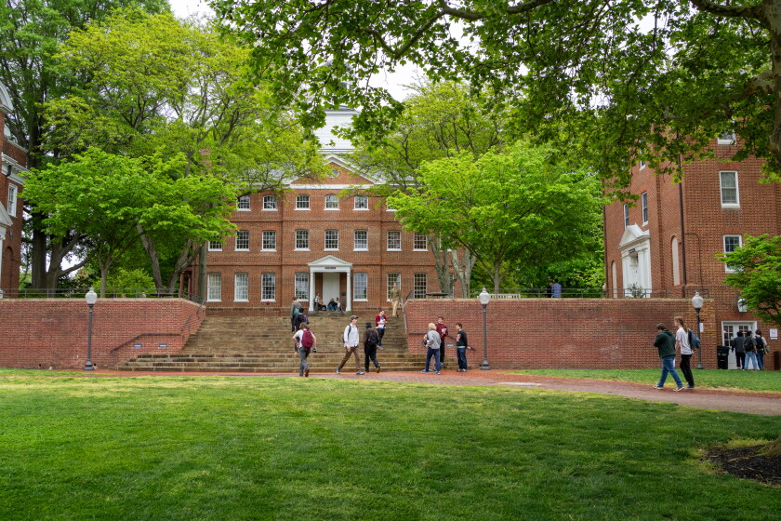
Not every aspect of St. John’s can be exported, but elements of the college’s approach are replicable — and finding fans.André Chung for The Chronicle
Some colleges are attempting to create these environments through academic programming. Cornerstone Integrated Liberal Arts, a “transformative texts” program begun at Purdue University in 2018, has proved so popular it is being replicated at dozens of two- and four-year institutions, with support from the Teagle Foundation. The Center for Liberal Arts Work at Anne Arundel Community College, in Maryland, for example, has helped faculty members embed transformational texts in general-education courses.
Hitz has her own version of this effort, called the Catherine Project. She created it after publishing her book, Lost in Thought: The Hidden Pleasures of an Intellectual Life, in 2020 and receiving questions from readers on how they, too, could live the life of the mind. This spring the project enrolled 1,600 readers in its free, online Great Books learning communities.
One of Langston’s roles is to help to develop similar programming elsewhere. She is advising projects in South Korea, which is dealing with tech saturation just as in the United States. She is on the advisory board of the Touchstones Discussion Project, started by three St. John’s tutors in the 1980s to build collaborative discussion skills in K-12 and college, and which has reached more than six million participants in 47 countries.
I don’t think we spend enough time talking with students about how what we’re doing is supposed to be challenging.
She is also on the board of the Great Questions Foundation, founded in 2019 by Ted Hadzi-Antich Jr., who began it after experimenting with ways to better engage students in his history classes at Austin Community College, where he is an associate professor of government and humanities.
When he began teaching an introduction to American government course at the college in 2007, Hadzi-Antich, a 2004 St. John’s graduate, was handed a textbook and the publisher’s PowerPoint slides, and, as he put it, went through the motions of being a professor. It bored him and it bored his students.
After a couple of semesters, he tried recreating what he had experienced at St. John’s, putting people in a circle to talk about a great book. He began with the Federalist Papers. “It was like somebody just woke the students up,” he recalls.
He went on to introduce students to a slew of other authors, including Plato, Alexis de Tocqueville, W.E.B. Dubois, and Martin Luther King Jr. He provided more structured questions than students at St. John’s receive, he says, which is necessary when teaching a course like this in a conventional college.
When Austin Community College introduced a mandatory student-success course, Hadzi-Antich proposed an option that infuses elements of the St. John’s approach. By the end of this year, he says, about 6,000 students will have completed this Great Questions seminar and about 160 faculty members will have gone through a six-week training to teach it. Another 4,000 students have taken a Great Questions Journey course, an option for those who want discussion-based, transformative-text classes, in a variety of disciplines.
Both Teagle and Mellon have helped scale up the Great Questions Foundation, which so far has promoted discussion-based courses on 70 community-college campuses.
Hadzi-Antich is sometimes asked whether one course is enough. It’s not, he says. But it’s a start. When students get a taste of what authentic learning can be, they want more of it, and may seek it out.
For a small college, St. John’s has a big footprint. That comes as no surprise to those who know it well, particularly in a fatigued, AI-obsessed world.
“To sit with other people and have conversations face to face, in which you are listened to respectfully and also are accountable for what you say, and real community is formed,” says Langston. “This is a deep hunger and a deep need.”


Beth McMurtrie
Beth McMurtrie is a senior writer for The Chronicle of Higher Education, where she focuses on the future of learning and technology’s influence on teaching. In addition to her reported stories, she writes a weekly Teaching newsletter about what works in and around the classroom. You can sign up here to receive the Teaching newsletter in your inbox on Thursdays. It’s free, and it helps us connect with our readers. Email her at beth.mcmurtrie@chronicle.com and follow her on LinkedIn.

