Holocaust and Genocide
SPRING 2017: HIST 595 ~ MWF 10:30-11:20 UNIV 301

“This story should not have happened – it did. We believed such stories cannot happen again – they are.”
-Judith Sherman, Say the Name

Professor Klein-Pejšová (PAY-shova)
Email: rkleinpe@purdue.edu
Office: University Hall 022
Office hours: W 2-4pm, or by appointment

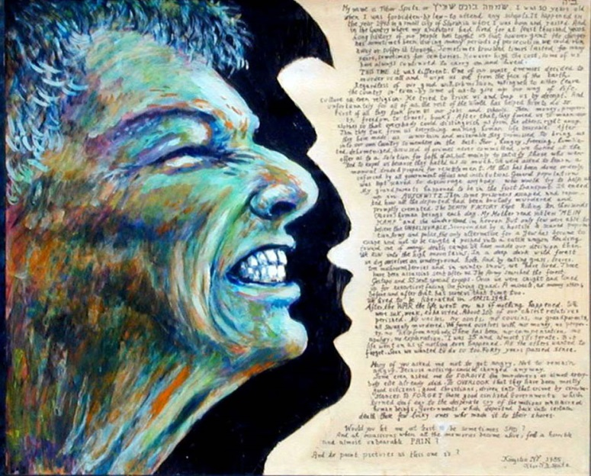
Artobiography by Tibor Spitz
The implications of the attempted destruction of European Jewry by the Nazis during the Second World War, what we term the Holocaust – along with millions of Roma (Gypsies), Poles, Russians, homosexuals, the handicapped, and others – are terrifyingly far-reaching. Genocide and ethnic cleansing are central to our understanding of the twentieth century. This course examines the historical origins and practices of genocide, centering on the causes and nature of the Holocaust as historical event, including its aftermath, problems of its representation and commemoration. We will work through a comparative framework to explore the Armenian genocide during World War One, and the cases of Rwanda and Yugoslavia in the 1990s. We will make use of primary sources and secondary literature, fiction, memoirs, film and other media in the course of our examination.
Required Texts:
• Eric D. WEITZ, A Century of Genocide (Princeton UP, 2003) [listed as WEITZ]
• Mahmood MAMDANI, When Victims Become Killers (Princeton UP, 2001) [MAMDANI]
• James WALLER, Becoming Evil, second edition (Oxford, 2007) [WALLER]
• Jan T. GROSS, Neighbors (Penguin, 2002) [GROSS]
• e-resources: Available on Blackboard. Marked with an asterisk [*] on the syllabus.

Attendance Policy:
Attendance at all class sessions is mandatory. Arrive on time. An attendance sheet will be passed around to sign at the beginning of class. More than four (4) absences will result in a grade penalty (1/2 of a letter grade) for each subsequent unexcused absence. Unexcused means undocumented by a doctor's note, or other valid form of documentation. If there is an occasion where you must leave early, notify me before class starts and sit near an exit. Be courteous. Do not disrupt the professor or your fellow students. Put away all electronic devices unless otherwise specified. Be prepared to participate.

Course Requirements:
- Reaction Logs (RL) (35% of course grade): You will write reaction logs (1-2 pages max) answering the question of the week, based on the readings. Reaction logs are due at the beginning of class on Fridays, typed, and in hard copy. You will receive a grade for each entry. The final cumulative grade will be posted on blackboard. On your book review week, you are not responsible for that week's reaction log.

- Book Review and presentation (25% of course grade): You will write a 5-page book review of a book chosen from those listed on the course schedule. The book review should include identification of the author and the author's credentials, discussion of the book's argument (or main message), the author's most important observations and conclusions, discussion of sources (or background for novels), and what is new and/or distinctive about the method, argument, style, conclusions. The book review will be due on the Wednesday corresponding to the topic on the course schedule, which is also when you will present the book to the group.

- Research Paper and presentation (40% of course grade): You will write a 12 page research paper on a relevant topic you propose, subject to approval. Your paper proposals (a paragraph outlining the topic, questions you intend to ask, sources you intend to use) are due on Monday, February 20th at the beginning of class. Your papers are due on Monday, April 17th at the beginning of class. We will hold a lightening round mini-conference during the last week of class, when you will each have a chance to present your paper topic and conclusions.

Written work for this course must adhere to the following format: double-spaced, one-inch margins, in 12 point Times New Roman font, paginated, proofread, and including Chicago Style footnotes for the book review and research paper. Assignments are due at the beginning of class. No email attachments. Late papers will be penalized by 5 points for each day late.

• Cheating / Plagiarism: Plagiarism refers to the reproduction of another's words or ideas without proper attribution. Cheating, plagiarism, and other forms of academic dishonesty are serious offenses, and will result in a failing grade and notification of the Dean of Students Office. Don't do it.
• Course evaluations: During the 15th week of classes, you will receive an official email from evaluation administrators with a link to the evaluation site. You will have two weeks to complete the evaluation. I do not see your evaluation until after grades are submitted.
• Disclaimer: In the event of a major campus emergency, the above requirements, deadlines and grading policies are subject to changes that may be required by a revised semester calendar. Any such changes in this course will be posted on Blackboard once the course resumes or can be obtained by contacting the professor via email.
*Email etiquette: Outside of class or office hours, communicate with your professor by email. State the reason for your email in the subject line (ex: “question about essay”). Include a full salutation (ex: “Dear Professor”), and closing with your full name (ex: “Sincerely, Eleanor Roosevelt”). Use full sentences, correct grammar, and punctuation. If you fail to follow this etiquette, I will not respond to your email. I will usually respond to your emails within 24 hours, with the exception of weekends.
Schedule of Classes
Week 1: Genocides in the Twentieth Century
M, 1/9: Introduction and Overview: Confronting the Silence
• Dan Pagis, "Written in Pencil in the Sealed Railway-Car"
W, 1/11: WEITZ, "Introduction: Genocides in the Twentieth Century"
F, 1/13: Robert Melson, "Introduction: Overview and Major Themes"*
•RL#1: Where do you see the major points of agreement and/or disagreement between Weitz and Melson in their main arguments and methods for studying genocides?

Week 2: Race and Nation
M, 1/16: No Class – Martin Luther King, Jr. Day
W, 1/18: WEITZ, ch1, "Race and Nation," pp. 16-42
F, 1/20: WEITZ, ch1, "Race and Nation," pp. 42-52
• Zimmerer, "The First Genocide of the Twentieth Century"*
•RL#2: What is modern about understanding and organizing human difference according to race and nation? How do colonialism and its legacies contribute to our understanding of genocide?

Week 3: The Armenian Genocide
M, 1/23: Robert Melson, ch.5, "The Turkish Revolution and the Armenian Genocide"*
W, 1/25: • WALLER, "Dovey's Story," pp. 54-58
• WEITZ, "An Armenian Prelude," pp. 1-7
@Book: Peter Balakian, Black Dog of Fate: A Memoir (1997) _______________________
F, 1/27: Robert Melson, ch.8, "Similarities and Differences between the Armenian Genocide and the Holocaust"*
•RL#3: Why was the Young Turk regime an "unmitigated disaster" for the Armenian people?

Week 4: What is Extraordinary Evil?
M, 1/30: WALLER, pp. 9-24, 33-53, 59-91
W, 2/1: WALLER, pp. 137-161, 196-220, 230-271
@Book: Claudia Card, Atrocity Paradigm (2002) _________________________________
F, 2/3: Milgram, "Behavioral Study of Obedience"*
In-class viewing of The Wave
•RL#4: How does Waller explain why some commit extraordinary evil?

Week 5: What were the preconditions for the Holocaust?
M, 2/6: WEITZ, ch.3, "Nazi Germany," pp. 102-114
W, 2/8: Schleunes, "The Year 1933: Revolution or Continuity in German History?"*
@Book: Richard Hamilton, Who Voted for Hitler? (1982) _________________________
@Book: Richard Bessel, Germany after the First World War (1993) __________________
*Human Rights Lab TBA
F, 2/10: Lucy Dawidowicz, "The First Stage: Anti-Jewish Legislation"*
•RL#5: Was 1933 a revolution in Germany?

Week 6: How did Nazi Germany seek war and systemize its persecution of targeted groups?
M, 2/13: WEITZ, ch.3, "Nazi Germany," pp.114-124
W, 2/15: Nora Levin, ch.4, "The Jews of Germany: 1933-1938"*
@Book: Marion Kaplan, Between Dignity and Despair (1998) _______________________
@Book: David Bankier, The Germans and the Final Solution (1992) __________________
F, 2/17: Lucy Dawidowicz, From that Place and Time, “Flight”*
"The Reichsvertretnung Program after the Nuremberg Laws"*
•RL#6: How did Nazi Germany systemize its persecution of targeted groups?

Week 7: How did the Nazi German Empire expand? How did the war differ geographically?
M, 2/20: Bergen, ch.5, "Experiments in Brutality, 1939-1940"*
•RESEARCH PAPER PROPOSALS DUE
W, 2/22: Holly Case, “Territorial Revision and the Holocaust: Hungary and Slovakia during World War II”*
@Book: Dobroszycki, The Chronicle of the Łodz Ghetto, 1941-1944 (1984) _____________
@Book: Knowles, et al, eds., Geographies of the Holocaust (2014) ____________________
@Book: Emily Greble, Sarajevo, 1941-1945 (2011) ______________________________
F, 2/24: Lucy Dawidowicz, “The Ordeals of the Ghettos in Eastern Europe”*
•RL#7: In what ways did Poland become a testing ground for Nazi policies? How did territorial concerns affect Nazi policies?

Week 8: How did Nazi Germany turn to a "War of Annihilation"? How did Nazi Germany and its Collaborators carry out the "War of Annihilation"?
M, 2/27: WEITZ, ch.3, “Nazi Germany,” pp.124-143
•Tim Snyder, Bloodlands, “The Nazi Death Factories”*
W, 3/1: Jeffrey Veidlinger, In the Shadow of the Shetl, “Life and Death in Reichskommissariat Ukraine”*
@Book: Jan Grabowski, Hunt for the Jews (2013) ________________________________
@Book: Heinz Heger, The Men With the Pink Triangle (1980) ______________________
F, 3/3: •Jacob Gladstein, poem, “The Dead Do Not praise God”*
•Sara Nomberg-Przytyk, short story, “Esther’s First Born” *
•RL#8: How do the week’s readings reflect the turn to “war of annihilation”? What stands out to you?

Week 9: "A World in Flames"
M, 3/6: Bergen, ch.8, “Death Throes and Killing Frenzies, 1944-1945”*
István Deák, “A Fatal Compromise?”*
W, 3/8: Shik, “Infinite Loneliness: Some Aspects of the Lives of Jewish Women in the Auschwitz Camps According to Testimonies and Autobiographies Written Between 1945 and 1948”*
@Book: Imre Kertész, Fatelessness (2004) ______________________________________
@Book: Kazik, Memoirs of a Warsaw Ghetto Fighter (1994) ________________________
@Book: Nirenberg, Johann Trollmann & Romani Resistance to the Nazis (2016) ________
*Human Rights Lab TBA
F, 3/10: •Ruth Bondy, “Games in the Shadow of the Crematoria: The Children’s Barracks in the Birkenau Family Camp”*
• Zuckerman, “The Creation and Development of the ŻOB”*
•RL#9: What is resistance?

Week 10: No Classes M, 3/13 through F, 3/17 - SPRING BREAK

Week 11: "Is it possible to be simultaneously a Victim and a Victimizer?"
M, 3/20: Reading Jan Gross, Neighbors, pp. xv-94 – consult the footnotes!
W, 3/22: Reading Jan Gross, Neighbors, pp.95-end
@Book: Istvan Deak, Europe on Trial (2015) _______________________________
F, 3/24: Class discussion
•RL#10: How does this little book contribute to the study of genocide?

Week 12: Blood, Ashes, Displacement, Diaspora: Postwar
M, 3/27: Lucy Dawidowicz, From That Place and Time, “In the Land of Amalek”*
W, 3/29: Lucy Dawidowicz, From That Place and Time, “Saving Remnants”*
@Book: Anna Cichopek-Gajraj, Beyond Violence (2014) __________________________
@Book: Laura Jockusch, Collect and Record! (2012)______________________________
F, 3/31: Jeffrey Veidlinger, In the Shadow of the Shtetl, “A Kind of Victory”*
•RL#11: How did the experiences of surviving Jews in Germany and the USSR differ immediately after the war?

Week 13: Rwanda: What was the nature of the genocide?
M, 4/3: MAMDANI, “Introduction,” ch.3 “The Racializaton of the Hutu/Tutsi Difference under Colonialism,” and ch.5 “The Second Republic”
W, 4/5: MAMDANI, ch.7 “The Civil War and the Genocide”
@Book: Philip Gourevitch, We Wish to Inform You That Tomorrow We Will Be Killed With Our Families: Stories From Rwanda (1999) _________________________________
*Human Rights Lab TBA
F, 4/7: Jean Hatzfeld, Machete Season: The Killers in Rwanda Speak (selections)*
•RL#12: “In Rwanda…your neighbors killed you,” said a minister in the RPF-led government. To what extent does Neighbors help us understand the nature of the genocide in Rwanda?

Week 14: Yugoslavia: Genocide or Ethnic Cleansing?
M, 4/10: WEITZ, ch.5, “National Communism,” pp.190-209
W, 4/12: WEITZ, ch.5, “National Communism,” pp. 209-235
@Book: Misha Glenny, The Fall of Yugoslavia (3rd edition, 1996) ___________________
F, 4/14: Jeri Laber, “Bosnia: Questions About Rape” *
•RL#13: What are the main similarities and differences that you see between the events in Yugoslavia and Rwanda?

Week 15: What have we learned?
M, 4/17: RESEARCH PAPERS DUE – film clips
W, 4/19: WEITZ, “Conclusion”
F, 4/21: WALLER, “Conclusion”

Week 16: GLHRC, HRP Symposium, and Class Conference – Paper Presentations
*Sunday, 4/23: The Greater Lafayette Holocaust Remembrance Conference (GLHRC) – Atina Grossmann will deliver the keynote. More details to follow@ www.glhrc.org
*M, 4/24: Human Rights Program Symposium: Refugee Crises Past and Present – more details to follow. Attend instead of class on this day.
W, 4/26 and F, 4/28: In-class presentations

